Almaligner tutorial
Welcome to the Almaligner tutorial!
In this tutorial you will learn to extract bilingual terminology from a TMX file.

Prerequisites
All you need is the Almaligner application (download it here), the Java runtime environment (download it here) and a TMX file.
If you don't have a TMX file, you can download one from here (if the link doesn't work, get the file from the parent page. NB: you'll need to unzip the file once you've downloaded it.

Starting the app
Double click on Almaligner.jar to start the app, you'll see the main application window:
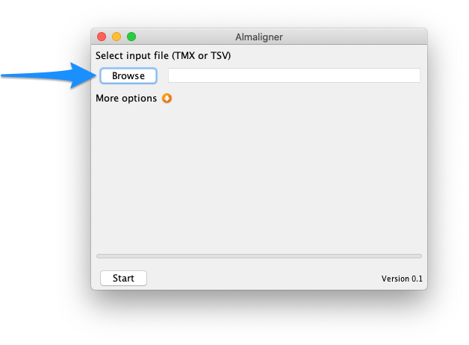
Next page

