Search Engine Key
N.B. We no longer provide support for API keys, below you'll find information about old versions of BootCaT that are no longer maintained.

Bing API version 7
In mid 2017 Bing updated the search engine API to version 7 which is supported since BootCaT version 1.0 (get the latest version of BootCaT here).

BootCaT 0.81 (and above)

Why do I need a search engine key?
BootCaT uses the Bing search engine to find web pages relevant to your domain. Unfortunately, in order to perform this kind of automated search, you need to register for an account that limits the number of queries that can be submitted (this limitation is enforced by Bing to prevent abuses).
At the time of writing, you can get a free account on the Microsoft Cognitive Services web site that lets you submit 1.000 free queries a month (every tuple you create with BootCaT becomes a query, so if you generate 50 tuples, when you click on “Collect URLs” in BootCaT you will use 50 of your queries). If you need more than 1.000 queries a month, you could try signing up for a paid account (see below) although this has not been tested yet: if you do decide to buy a paid account, you do it at your own risk.

What's a Key?
A key is a sort of password: it's a very long string of letters and numbers. Unlike a password, you don't get to choose what your key is, it's assigned to you and you can't change it.

How do I get a key
To get your free Bing Web Search key:
- visit https://www.microsoft.com/cognitive-services/en-us/apis and click on “Get started for free”
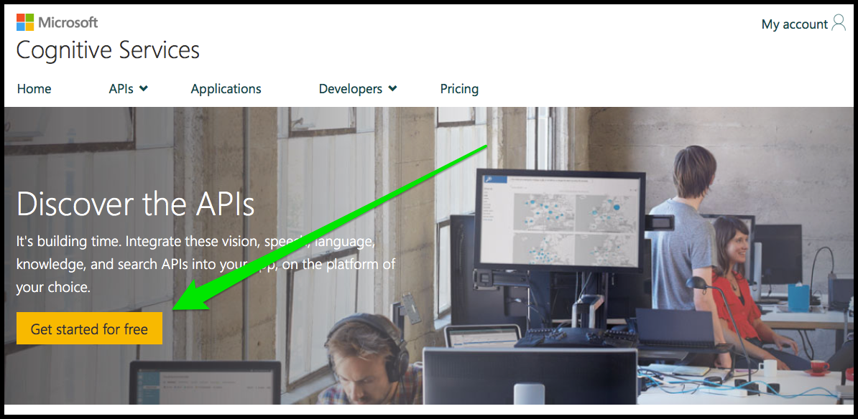
- then click on “Let's go”
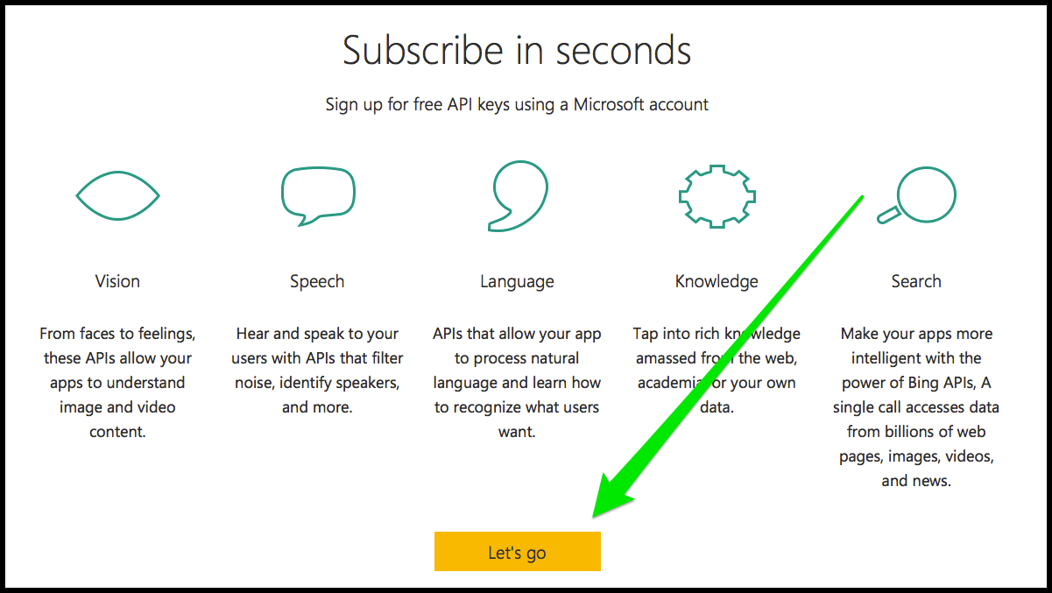
- either login with your existing Microsoft Account or create one for free
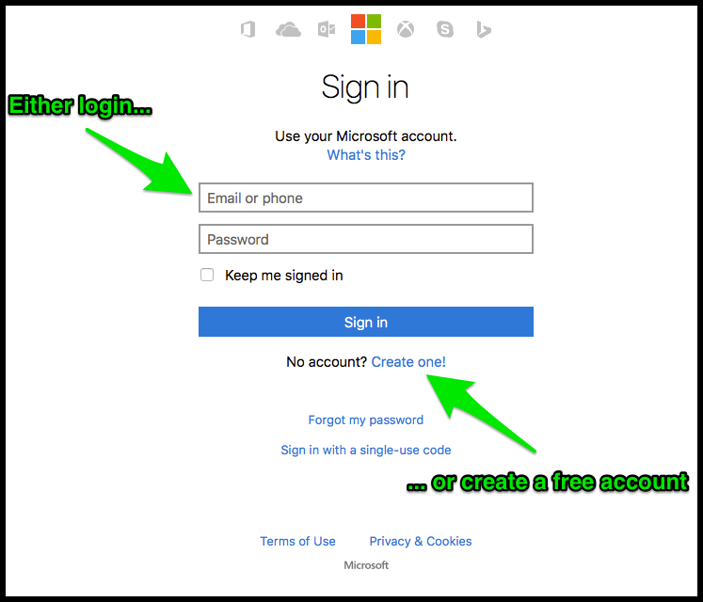
- click “Yes”
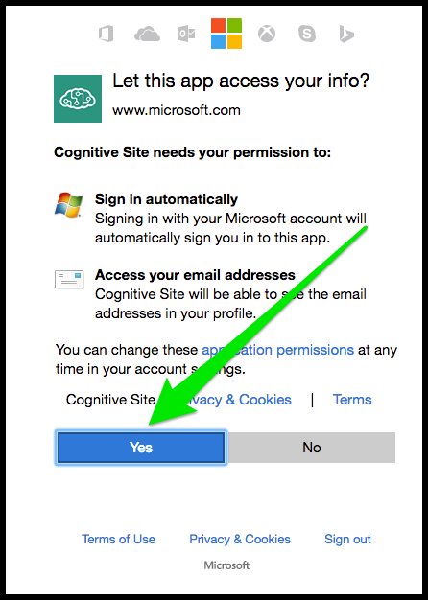
- scroll down and check “Bing Search Free”, then check “I agree to the Microsoft Cognitive Services Terms and Microsoft Privacy Statement” and click on “Subscribe”.
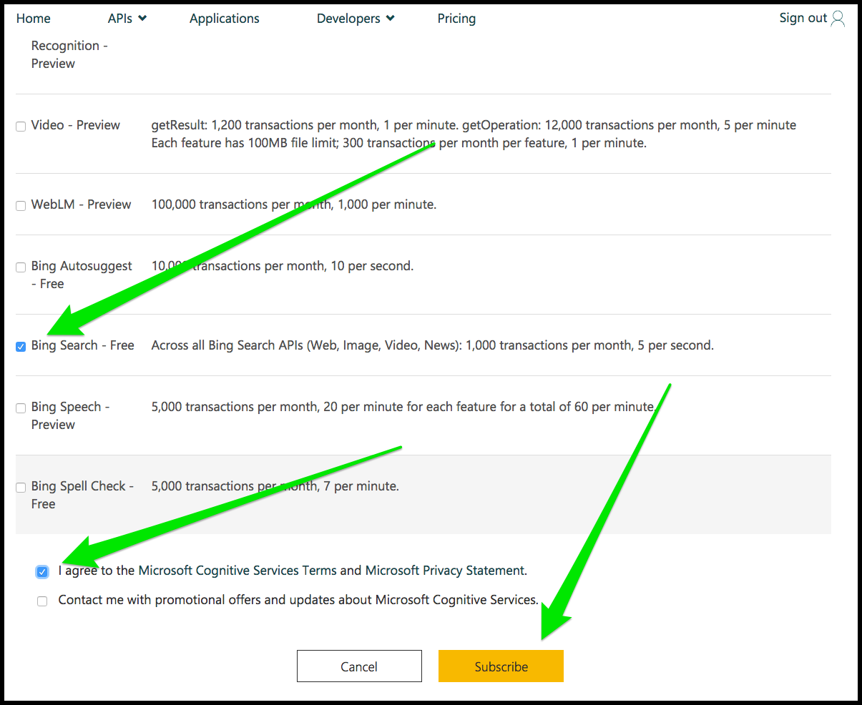
That's it, your search engine key is here, you need to click on “Show” to see it: it will be a 32-character-long string of letters and numbers.
YOUR KEY CANNOT BE XXXXXXXXXXXXXXXXXXXXXXXXXXXXXXXX
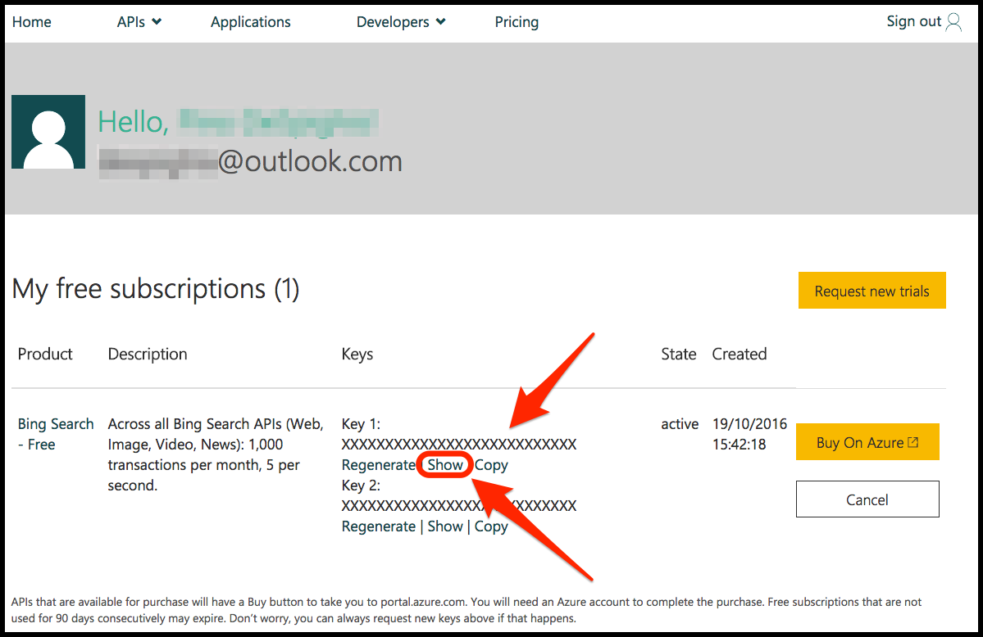
Now you can copy the key and paste it in the relevant field in BootCaT.

BootCaT and Bing are two very different things
BootCaT is a free software program developed by people at the universities of Bologna, Trento and Zagreb and is in no way affiliated to Bing, a commercial service owned by Microsoft. The main reason for using Bing to retrieve URLs is the fact that it offers a limited number of free queries a month: we don't get a cut if you buy a paid account from Microsoft, nor are we responsible for anything related to Bing.

BootCaT version 0.71
BootCaT version 0.71 uses the “Windows Azure Marketplace AccountKey” which will STOP WORKING on December 15, 2016. You'll need to upgrade BootCaT al least to version 0.81 and get the new Bing Search API key (see above for more info on how to obtain this new key).
How to get a Windows Azure Marketplace AccountKey (outdated info, no longer relevant)

BootCaT version 0.60
Version 0.60 stopped working August 1, 2012, If you want to use BootCaT you need to upgrade to the latest version
See this page to determine which version of BootCaT you are using

