Bing AppId

Soon BootCaT will stop working!
On April 12, 2012 Bing announced the release of version 2 of their Search API. With this new version, the search service on which BootCaT depends for retrieving URLs will no longer be free.
Bing stated that “The transition will begin in several weeks and will take a few months to complete […] At this time, you can continue using Bing Search API 2.0 free of charge. After the transition period, Bing Search API 2.0 will no longer be available for free public use.”
The bottom line is that soon BootCaT will probably stop working.
We're looking for alternatives, if you know any search API that can be a viable substitute, please let us know. You can contact us at bootcat@sslmit.unibo.it.

Why do I need an AppId?
At the end of June 2011 Yahoo terminated the free search service BootCaT had been using for years, so we were forced to find an alternative solution.
On August 5, 2011 version 0.6 of the BootCat front-end (which includes version 0.16 of the toolkit) was released. Starting from this version, the Bing search engine is used to retrieve URLs. Bing's service is not as generous as the one the now defunct Yahoo Search API used to provide, but it's the next best thing: you can use the service for free but an AppId is required for the system to work. To obtain an AppId you just need to register (for free) on the Bing website.
We realise this is not ideal, but there's really no alternative (that we know of, if you know of an alternative, please contact us): Google and Yahoo now require paid accounts to provide the kind of service BootCaT needs, Bing is free (at least for now).

BootCaT and Bing are two very different things
The authors of BootCaT (mostly people working at the universities of Bologna and Trento) are in no way affiliated with Bing (a commercial search engine controlled by Microsoft).
The page you are reading has been created to provide a simple explanation of what is needed for BootCaT to work. We are not responsible for anything related to Bing.

What's an AppId and how do I get one?
An AppId is a sort of password: it's a very long string of letters and numbers. Unlike a password, you don't get to choose what your AppId is, it's assigned to you and you can't change it.
To get your free Bing AppId:
- make sure you have a “Windows Live ID” (i.e. a Hotmail e-mail address), if don't have one already, you can sign up (for free) here
- visit http://www.bing.com/developers and click on “Sign in - Bing Search API”:
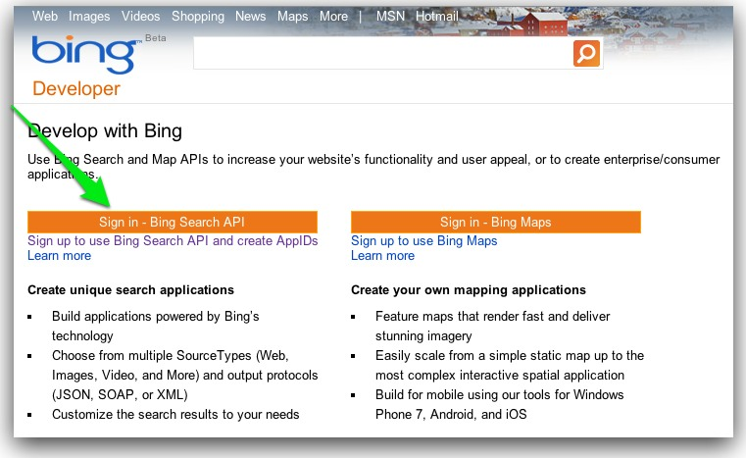
- login using you Windows Live ID:
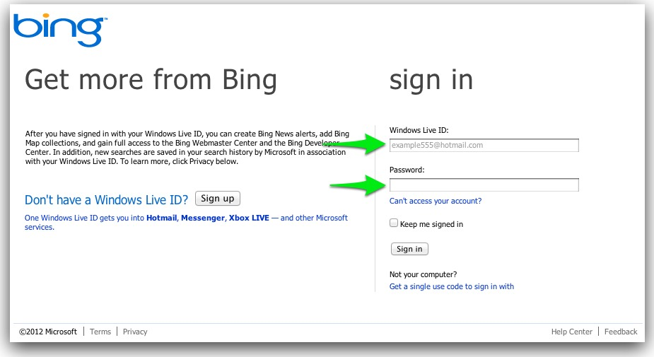
- in the next screen click “Add”:
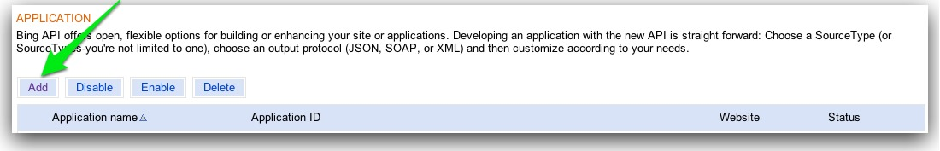
- fill out the registration form and click on “Save” (as you can see, only general information is required):
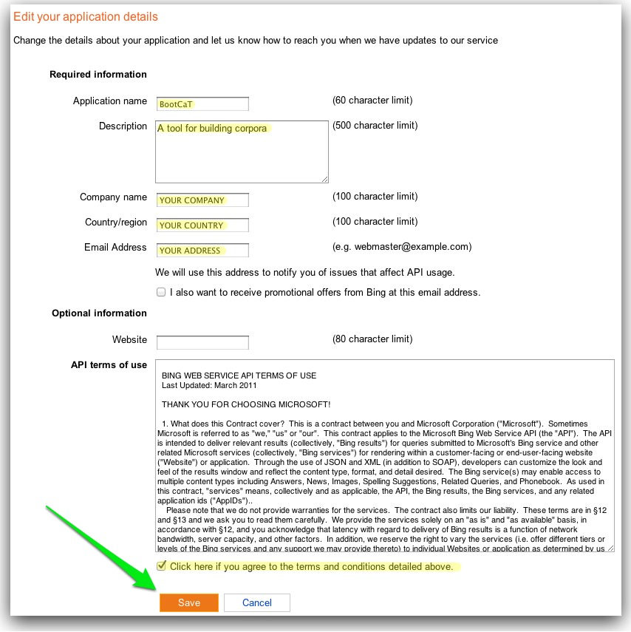

Where's my AppId?
Once you've filled out the form and clicked on “Save”, you should see something like this (your AppId will be in the area marked by the red line in the picture below):
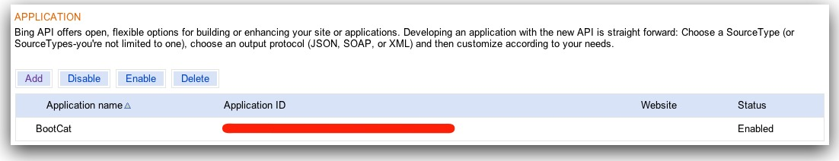
Sometimes the key doesn't appear immediately, just refresh the page by pushing the refresh button on your browser.
Remember that you don't need to create a new AppId every time you install BootCaT, you can use the same key on multiple computers.
NB: it's advisable to use copy/paste to insert the key in the relevant box inside BootCaT, you can use the key combination CTRL-C (copy) and CTRL-V (paste) on Windows and Linux or CMD-C (copy) and CMD-V (paste) on Mac.

